Web Design

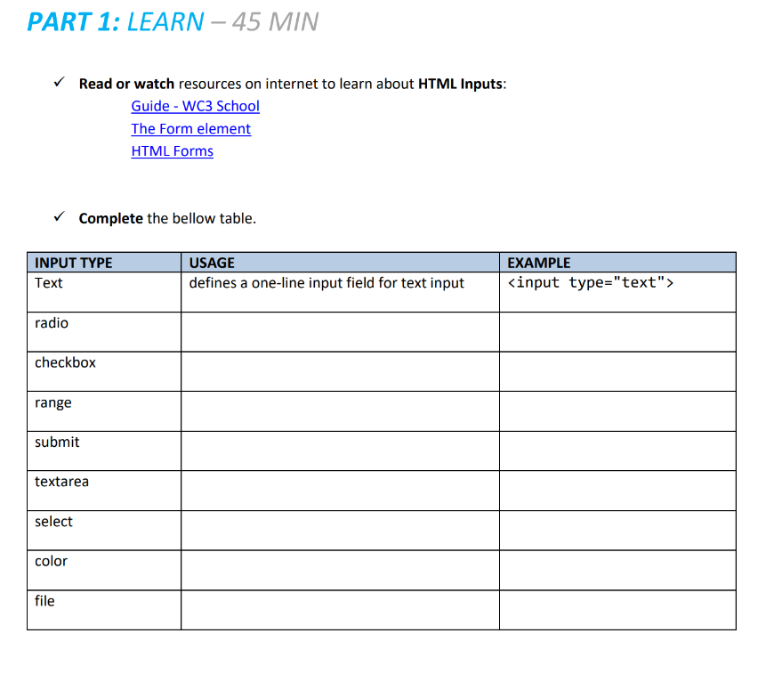
INPUT TYPE | USAGE | EXAMPLE
Text | Type normal text | <input type="text">
Radio | Choose one option | <input type="radio">
Checkbox | Choose many options | <input type="checkbox">
Range | Move a slider | <input type="range">
Submit | Send the form | <input type="submit">
Textarea | Type long text | <textarea></textarea>
Select | Pick from a drop down | <select></select>
Color | Pick a color | <input type="color">
File | Upload a file | <input type="file">

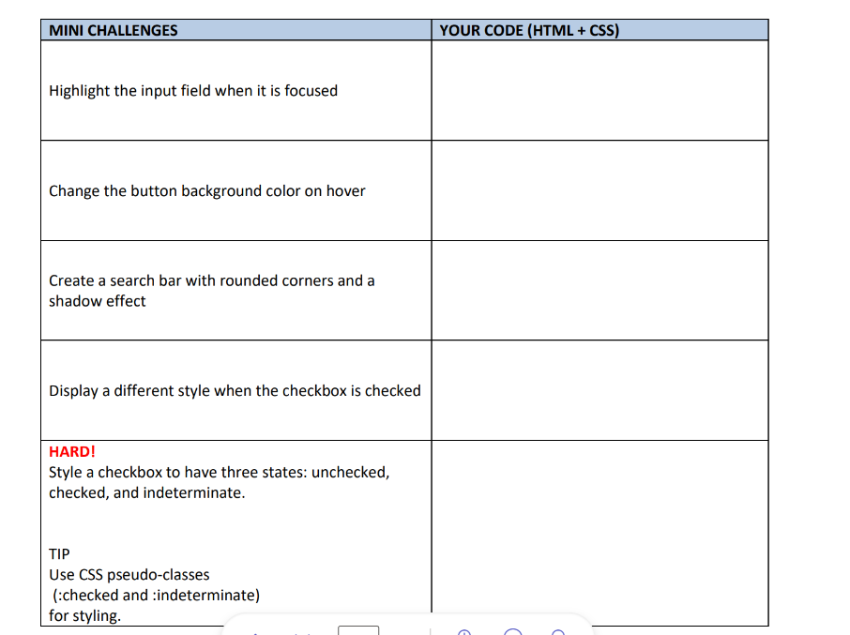1
<input type="text" class="box">

<style>
.box:focus {
outline: 2px solid blue;
}
</style>
2
<button class="btn">Click</button>

<style>
.btn:hover {
background: lightblue;
}
</style>
3
<input type="text" class="search" placeholder="Search">

<style>
.search {
padding: 5px;
border-radius: 10px;
box-shadow: 0 0 5px gray;
}
</style>
4
<input type="checkbox" id="cb">
<label for="cb" class="check-text">Check me</label>

<style>
#cb:checked + .check-text {
color: green;
font-weight: bold;
}
</style>
5
<input type="checkbox" id="tri" class="tri">

<style>
.tri {
width: 20px;
height: 20px;
}

/* checked */
.tri:checked {
outline: 2px solid green;
}

/* indeterminate */
.tri:indeterminate {
outline: 2px solid orange;
}
</style>

<script>
document.getElementById("tri").indeterminate = true;
</script>

